- Suppose that the figures below represent closest packing arrangements of anions. Identify the locations where cations could be coordinated with 2, 3, 4, or 6 anions. In the location where you would place the cation, write its coordination number. (8 points)

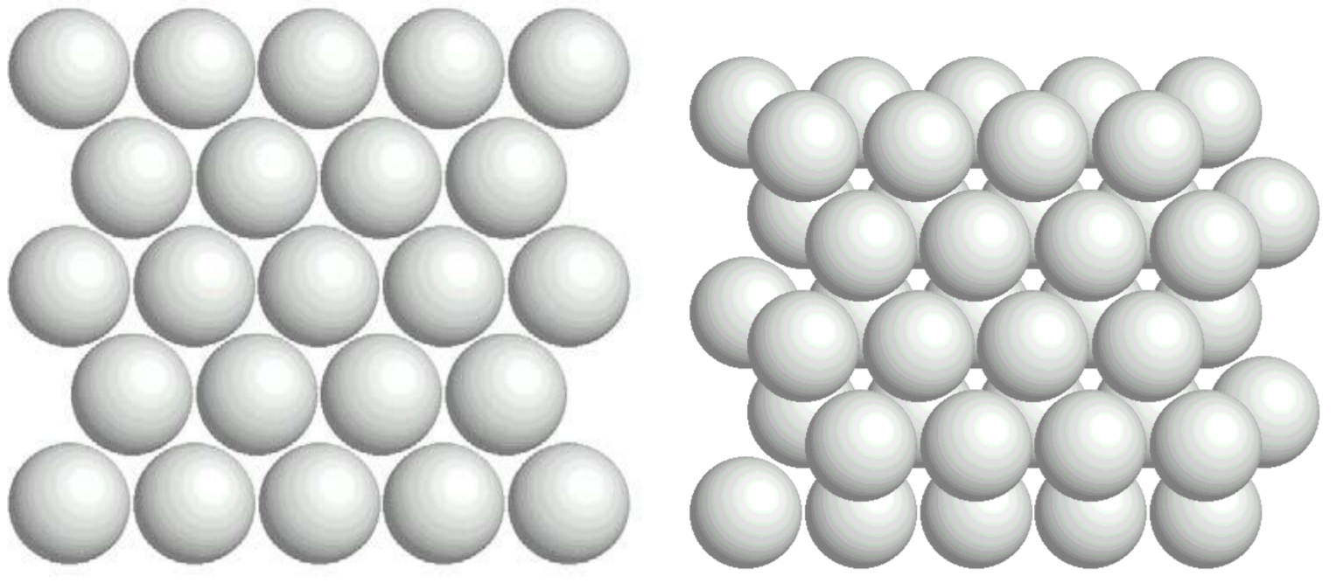

- For the following stereo diagrams determine the crystal system and the point group based on their symmetry elements. (4 points)
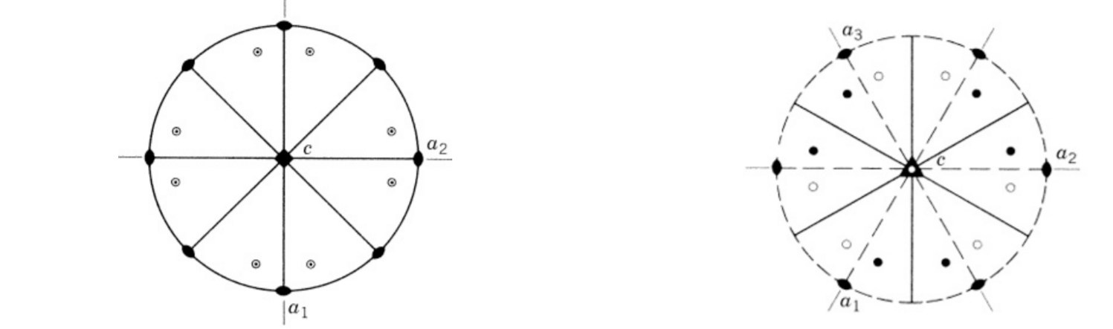
Crystal System: ___________________ Crystal System: ____________________
Point Group: _________________ Point Group: __________________

- For the following, name the crystal form. (3 points)
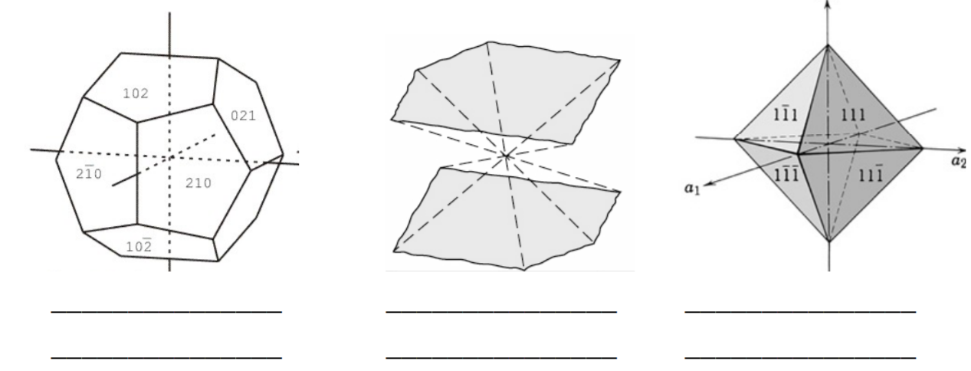

- We discussed Pauling’s Rules in class recently. Using what you learned and the table of Rc/Ra values attached, answer the following. Forsterite (Mg2SiO4) is a common rock-forming mantle mineral found on Earth, Mars, and in meteorites.
Assume the elements have the following radii:
O = 1.29Å Mg = 0.80Å Si = 0.35Å

  - Determine the coordination numbers of Mg and Si. Explain how you determined their coordination numbers. (3 points)
  - Determine the number of Mg and Si atoms to which each O is bonded. (2 points)
  - What are the average MgO and SiO bond strengths, which is strongest? (3 points)
- Assume the lengths of the edges (sides) of a unit cell for a newly discovered mineral are…
a = 6Å b = 6Å c = 8Å
The axial intercepts are given for face A of the mineral. Calculate the Miller’s index for the face. You may find it easier to draw this out yourself by creating axes as you have been practicing in class. (5 points)
Face A axial intercepts are….
a = 2Å b = 4Å c = 4Å
- Draw your own pattern showing the following symmetry elements:
  - 2 mirror planes perpendicular to one another
  - 4-fold axis of rotation

Essay Question: Please submit an answer to the question typed, in 12-point Times New Roman font, and double spaced. You must have at least 3 sources. The sources should be cited at the end of your paper in MLA format and cited in text wherever necessary. Do not use direct quotes, paraphrase! The essay should be no more than 3 pages in length and no less than 2 pages in length. You will be graded on content, organization, and grammar/sentence structure.
We discussed biominerals in our last lecture. Choose one organism that biomineralizes (either controlled or induced biomineralization). After you have chosen the organism, research what material it biomineralizes, the process by which it biomineralizes, and the possible applications for material sciences for learning about this organisms biomineralization process.

